I Designed That……...

I make ideas work.

Peter A Smith
Mechanical Design Engineer
psmith47@nc.rr.com
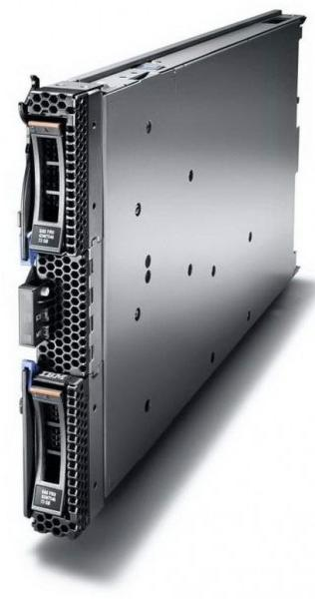
HS23 Blade

Two Intel Xeon E5-2600 processors and 16 Memory Dimms required a major redesign from predecessor HS22.
Custom twin processor ILM bracket, Patented changes to ILM layout (adopted by Intel) and redesigned cover and Chassis.
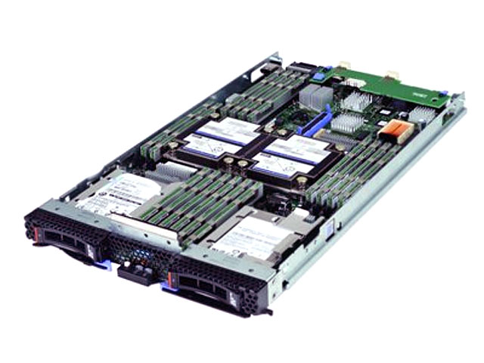

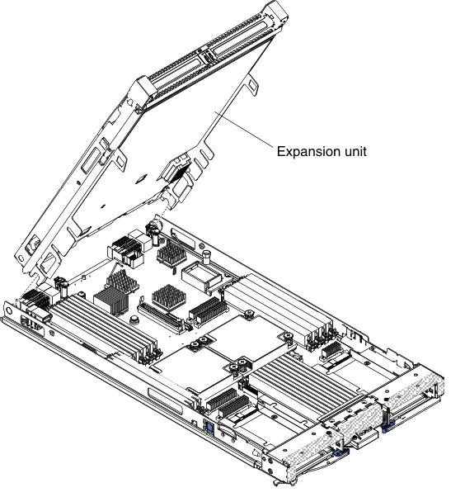

Expansion unit redesigned plus weight reduction measures to get maximum configurable assembly to be a one person lift in order to reduce service call costs.

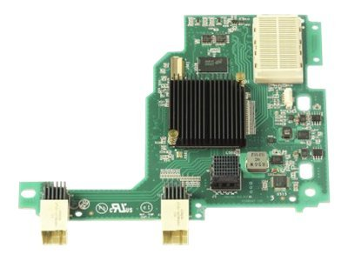
New 2+2 High Speed daughter and mezzanine cards with additional high speed connectors required redesign of mounting posts to allow both the new and legacy cards to be options.
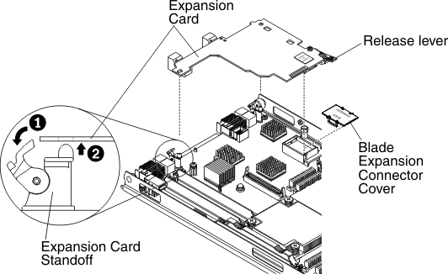
New card requires to be installed vertically and design had to ensure that incorrect installation would not result in damage to either the system board or daughter card

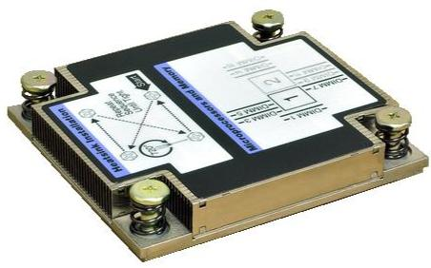
Increased processor mounting height required redesign of heat sink mountings to allow sufficient travel to ensure correct pre-load.

HS22 Blade
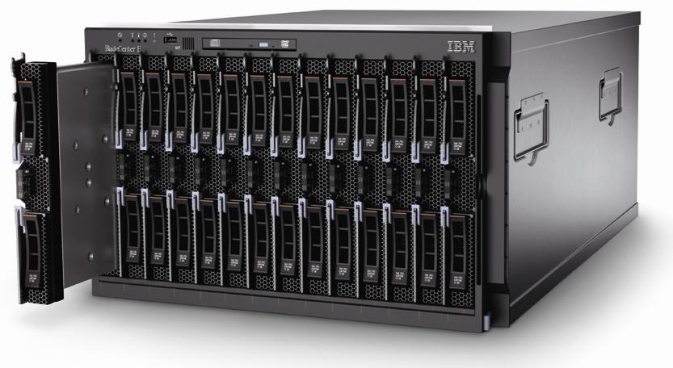
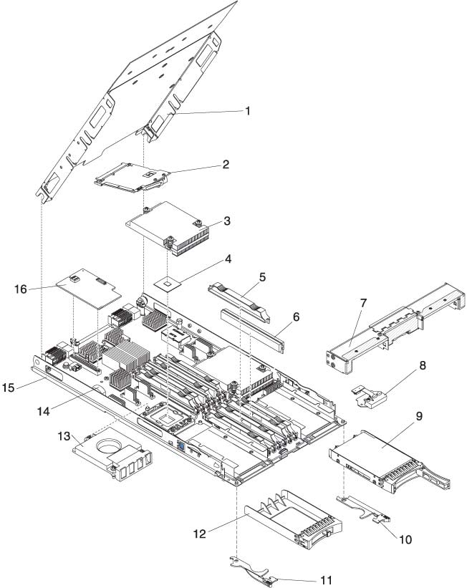
First Blade to have integral hot swap hard drives.
Resultant loss of air flow and interior space required innovative solution.
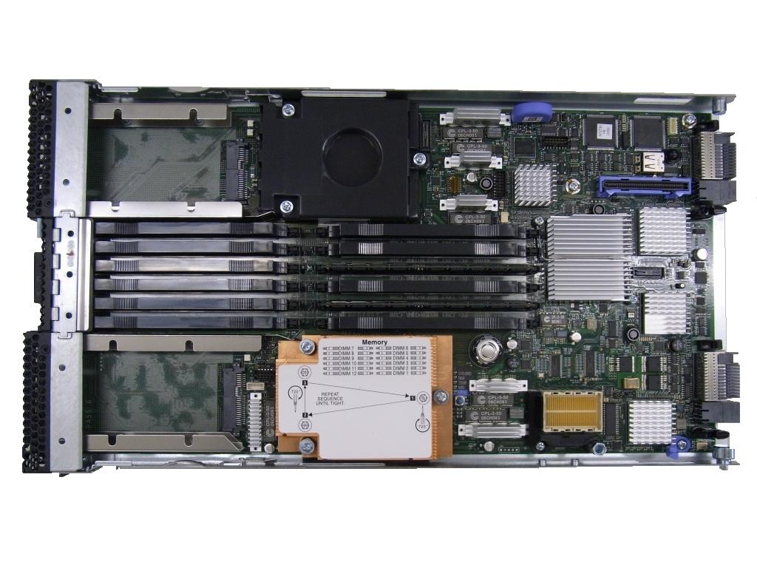
Drives were pushed forward alongside the installation handles and operator panel was miniaturized and placed between latches to minimize its effect on cooling. Front bezel incorporates hinged opening to allow access to Memory DIMM latches whilst maintaining required EMC performance.

HS22 Blade design received IBM Outstanding Technical Achievement award.
HS21 Blade
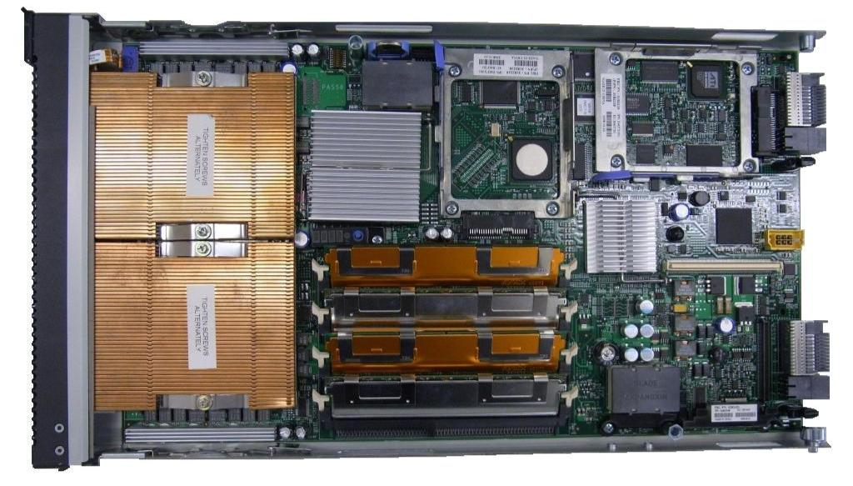
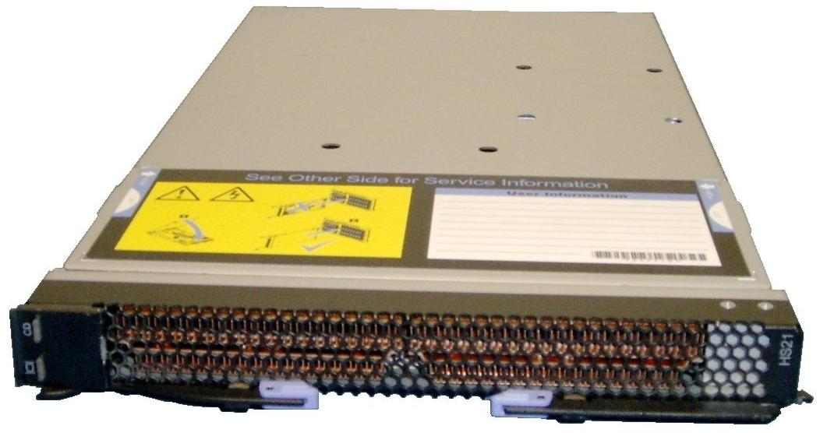
Design introduced new lower profile and cheaper handles, improved operator panel connector, more space efficient hard drive mounting trays and second GigArray connector for the optional Memory expansion blade.

New high speed daughter card profile to allow of new high speed and legacy daughter cards.
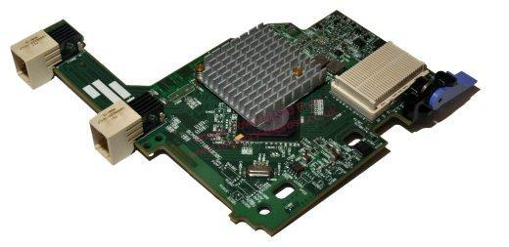
Integral lever allows for easy removal

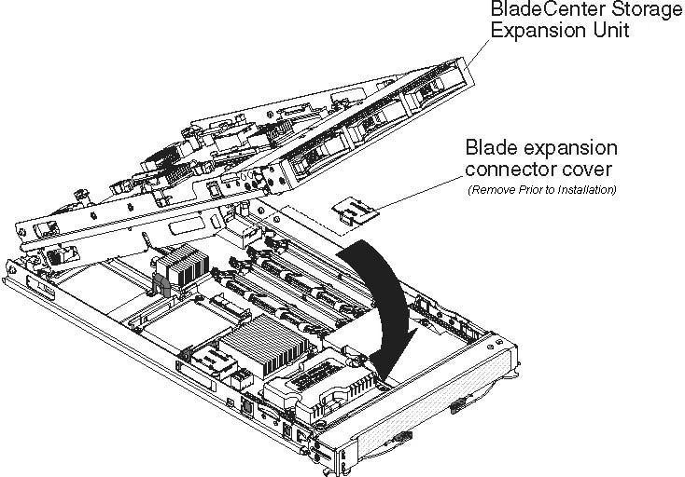
New blade Storage enclosure featured new hot-swap drive trays and high commonality of chassis parts with Memory expansion enclosure
eServer 32X
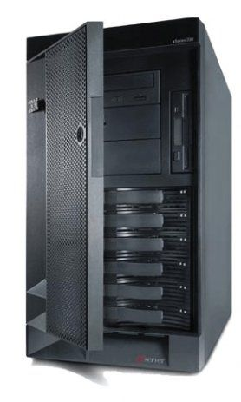

5U Rack or Tower server.
Same Bezels as prevous 5U Towers but redesigned chassis.

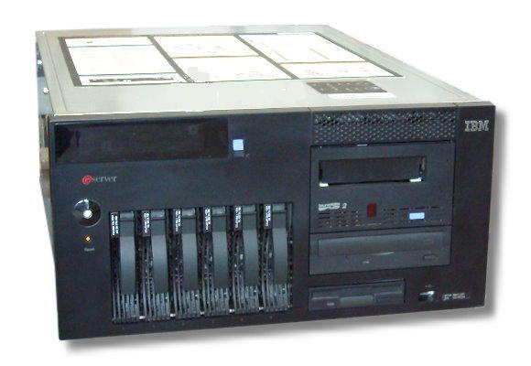

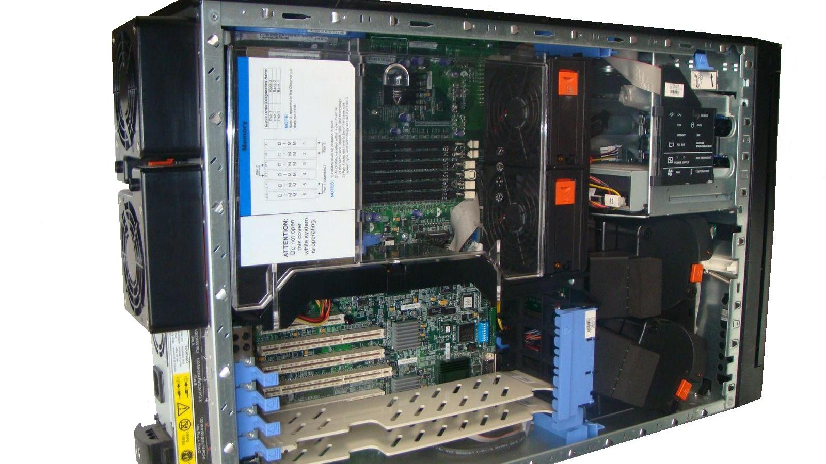
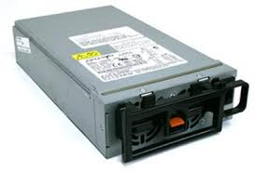
Larger System board, increased number of fans and higher capacity power supplies drive new chassis design

New hot-swappable (or optional cheaper non hot-swap) supplies now located under the system board.

System board mounted on metal tray and secured with single-action latch.
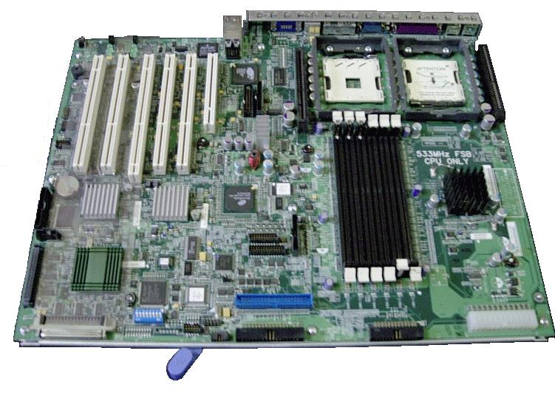
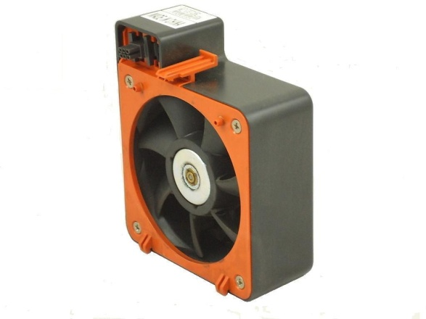
Space saved by moving rear fans outside of the chassis.
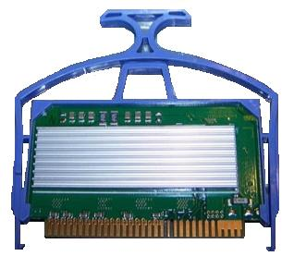

VRM clip allows easy installation and removal whilst still incorporating latching mechanism.
Netfinity 5600
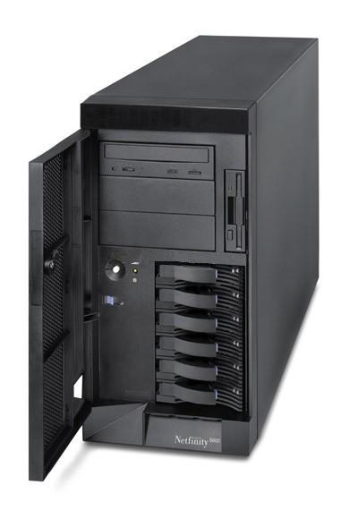
All new 5U design.
Horizontal Processor card with single lever install/remove mechanism.
Unique 5.25 device cage that allows correct orientation in both rack and tower configurations
Tool-less assembly and servicing.

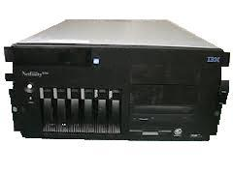

Option kit to convert Tower to rack as business grows.

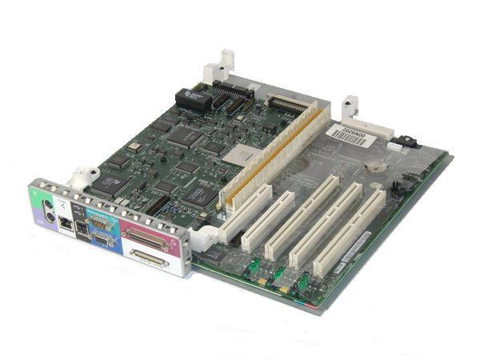

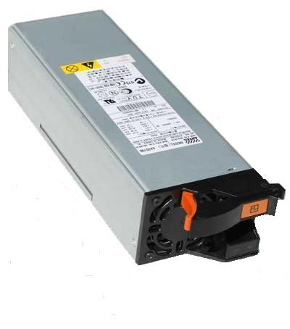
Standard hot swap power supplies and N+1 power backplane.

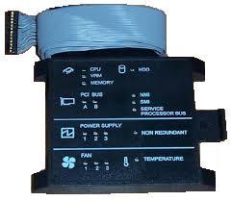

LED Lightpath diagnostics card visible without removing side cover door.
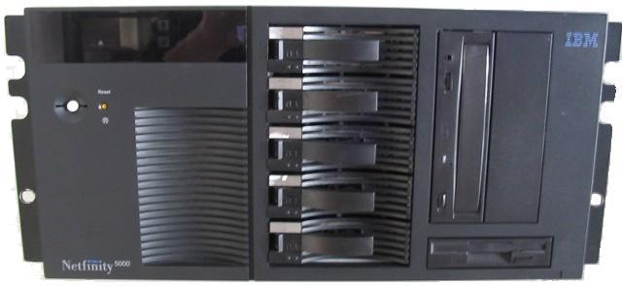
Netfinity 5000
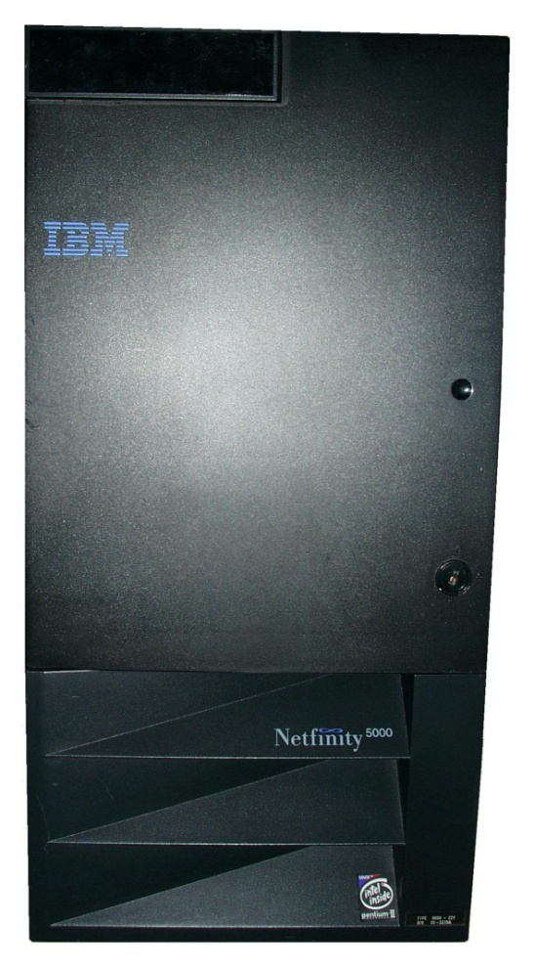

5U Rack or Tower
Heavy emphasis on ease of use and high quality appearance
Injection molded smoked polycarbonate door
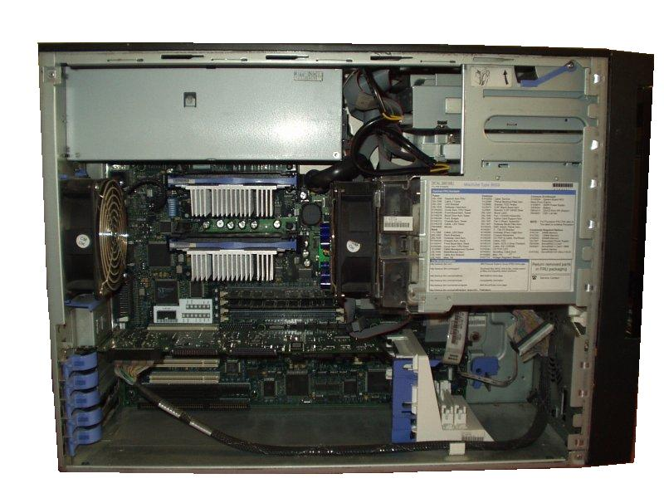

Tool-less assembly and servicing.
DASD signal cables routed beneath system board to improve airflow, reduce clutter and ease installation of option cards

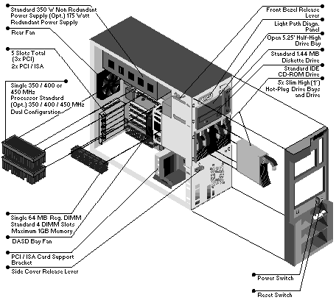

IBM Outstanding technical achievement award.
IBM “Make it easy” Award.
PC Server
325 and 330
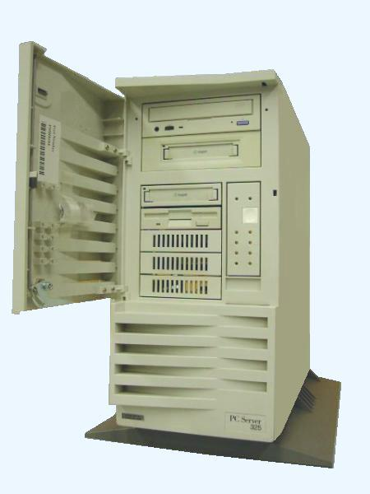

Major Redesign of earlier 315 and 320 models.
New chassis and bezels.
Reduced build and option installation times.

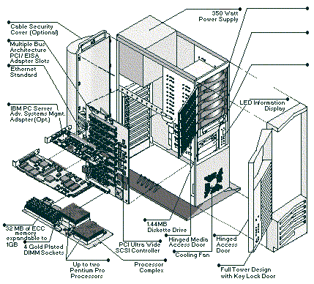
Processor card and early version of Lightpath diagnostics.
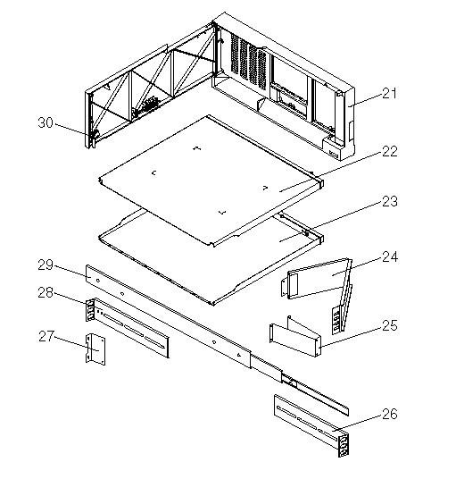

Rack Mounting kit for 325

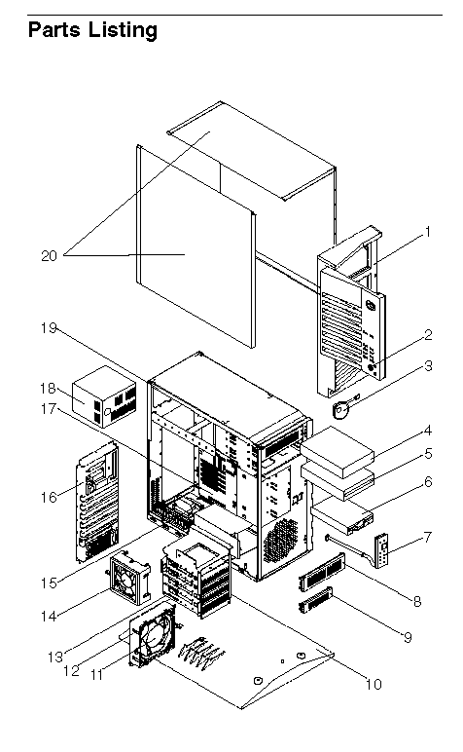
Redesign included all new bezels and doors and “swing-out” Hard File cage on 315 that reduced installation time of hard file options from 2 hours plus, to 5 minutes.
PS/2E
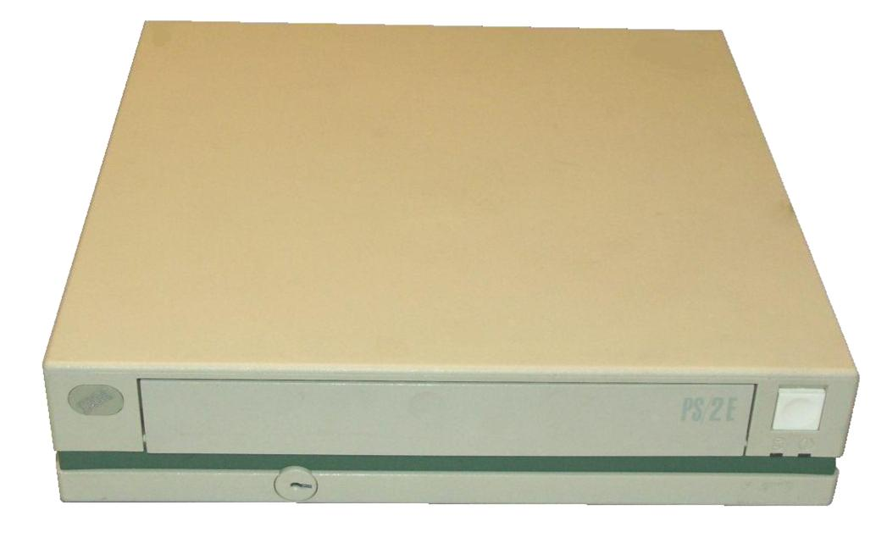
First ever Energy Star desktop Computer.
30W power consumption, no fan.

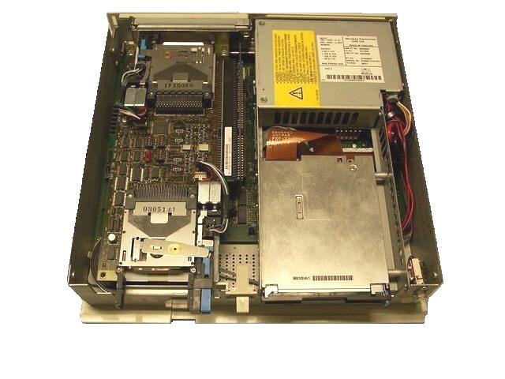
Injection Molded Clamshell casing with sheetmetal Chassis and internal structure.
Tool-less assembly and servicing.

PS/1 Pro
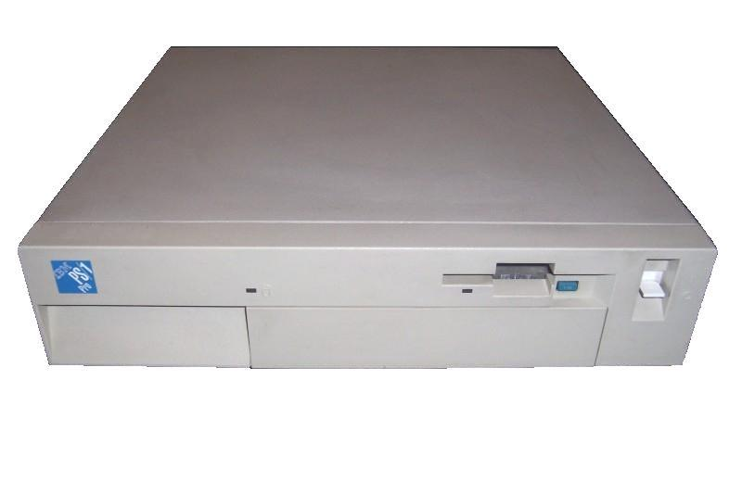
Coverset converted from existing PS/2 Model 30.
New injection molded plastic front, rear, DASD and blank bezels.

Cost reduced and innovative sheet metal mounting structure to allow 5.25 media option.
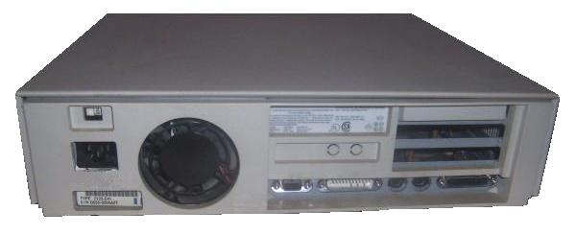

Designed to minimize costly changes to large chassis and cover tools.
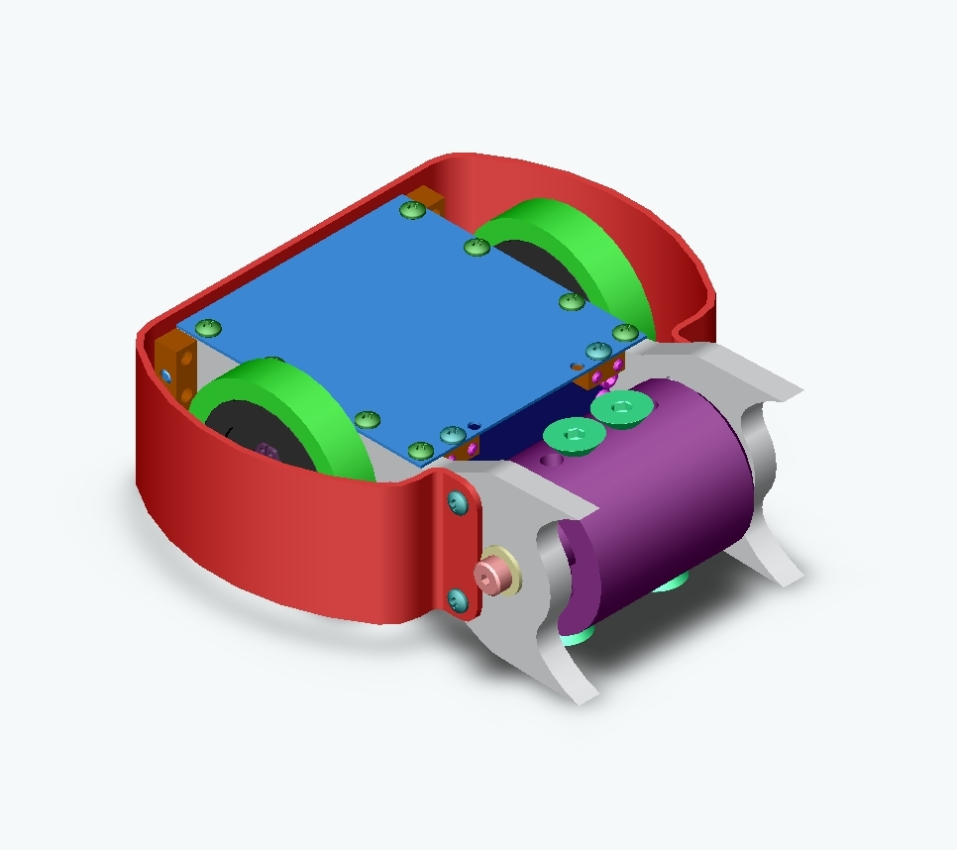
Designing is not just for work.
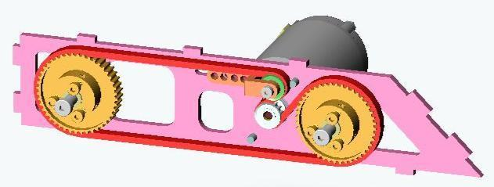

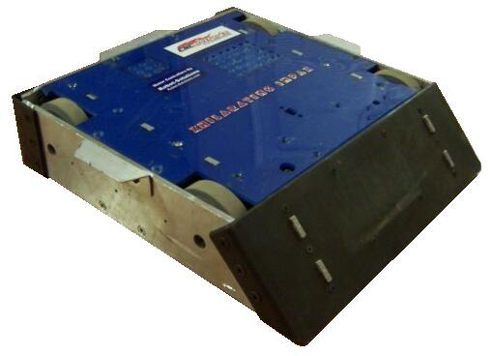
I design and build combat robots

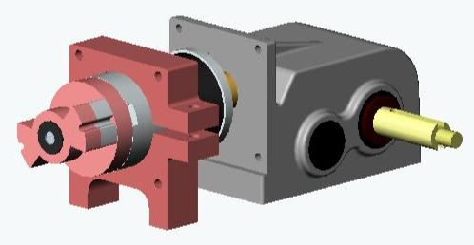
Adapting a power wheelchair gearbox to take a more powerful and higher RPM motor. Used in the drivetrain of a 220lb Full body spinner.

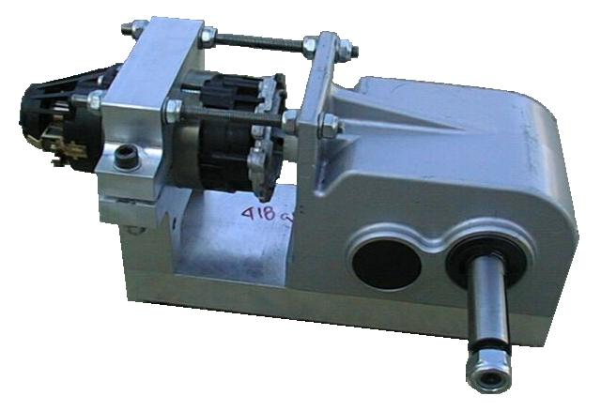

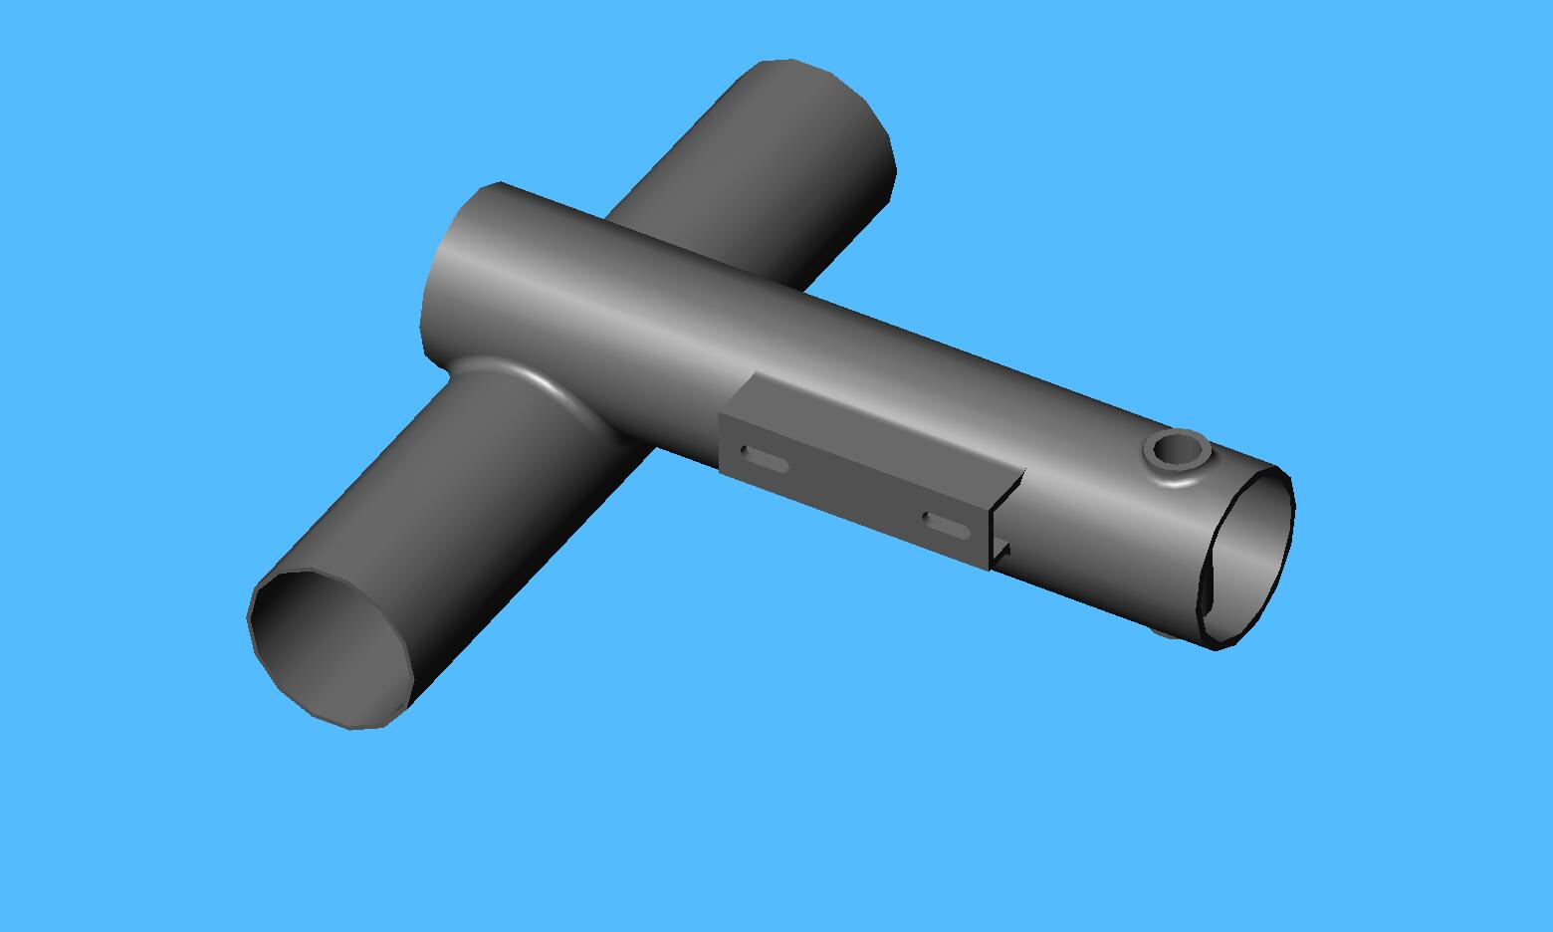

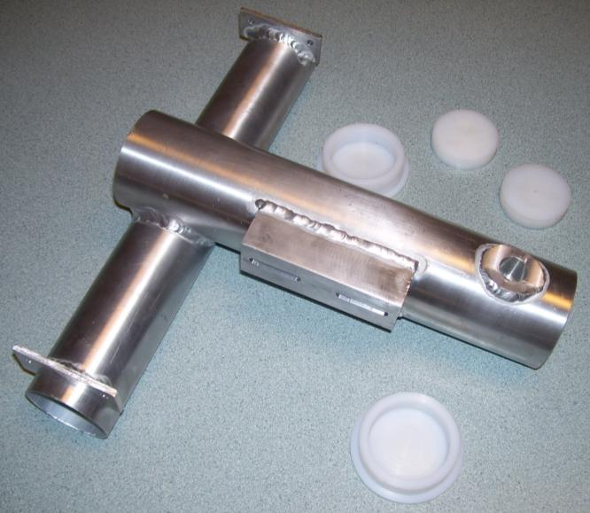
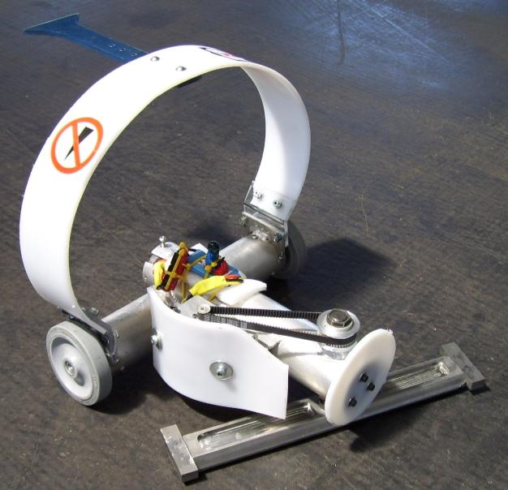
TIG welded 1/16” 6061 Chassis is the backbone of a design of a Horizontal blade spinner that was #1 in the National Rankings for three years.

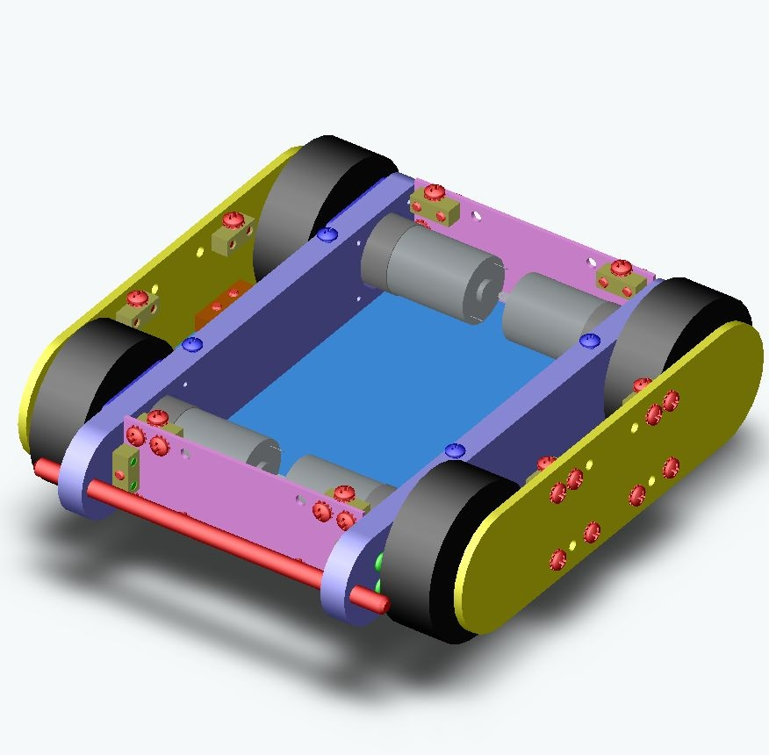
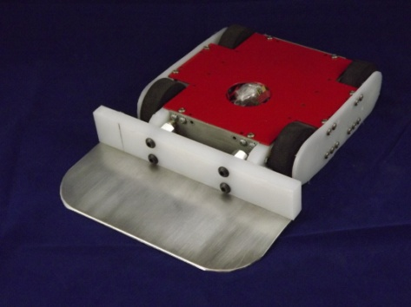
3lb class 4WD brick/wedge with interchangeable wedges to match opponents.
